Position Description
Manager, Policy and Research
Yoorrook Justice Commission
The Yoorrook Justice Commission (Yoorrook) is the first formal truth-telling process into historical and ongoing injustices experienced by First Peoples in Victoria since colonisation. Guided by its values and principles, Yoorrook will:
- Establish an official record of the impact of colonisation on First Peoples in Victoria.
- Develop a shared understanding among all Victorians of the impact of colonisation, as well as the diversity, strength and resilience of First Peoples' cultures.
- Make recommendations for healing, system reform and practical changes to laws, policy and education, as well as to matters to be included in future treaties.
Yoorrook is independent of government and the First Peoples’ Assembly of Victoria. It has been established as an independent Royal Commission under the Inquiries Act 2014. See here the Letters Patent that set out Yoorrook’s mandate.
Yoorrook is unique among Royal Commissions because, while it is for the benefit of all Victorians, First Peoples drove its design and remain at its centre.
Strategic Goals and Values
Yoorrook seeks to achieve truth, understanding and transformation. Yoorrook’s values guide the way it works.

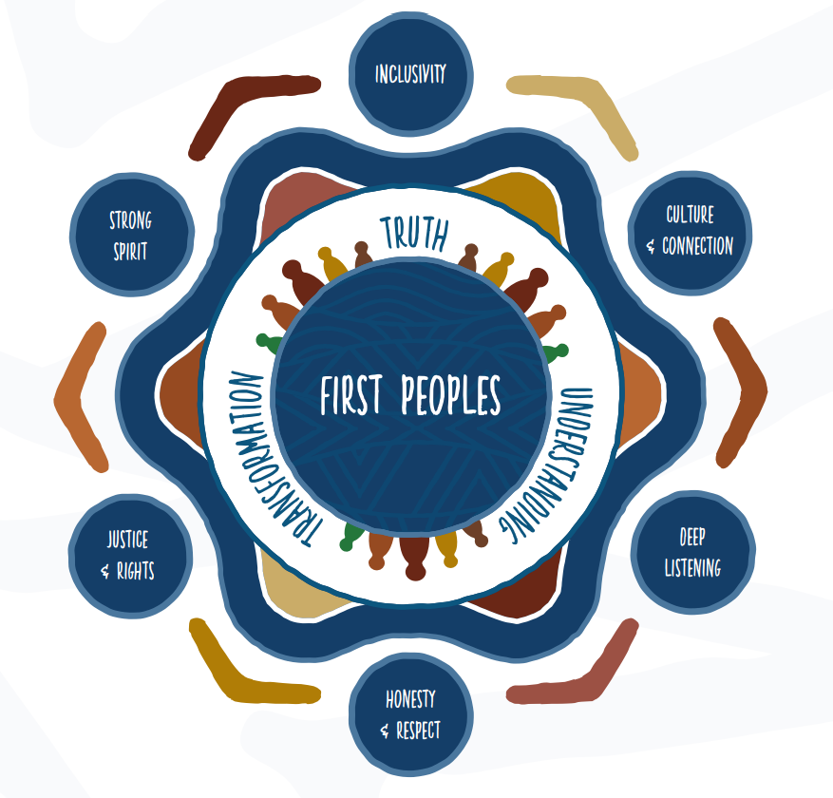
Position Summary
The Manager, Policy and Research supports the Director, Legal Policy and Research in providing strategic advice to Commissioners and the executive on Yoorrook’s policy and research priorities and managing and contributing to the work of the policy and research team.
The role is responsible for ensuring the delivery of research and policy projects under time pressure in a complex and sensitive environment; analysing submissions and other evidence; drafting background and issues papers, as well working on reports under the direction of the Commissioners. The Legal Policy and Research team is also responsible for developing policy options to support Yoorrook’s recommendations for systemic reform.
You must be a proactive self-starter with exceptional interpersonal skills. To succeed in this role, you will be someone who is outcomes focused, an exceptional writer and communicator; thrives on a challenge and working in a diverse multifaceted environment; and is passionate about truth and justice for First Peoples in Victoria.
Yoorrook’s mandate requires it to complete its work by 30 June 2024. Yoorrook has recommended to the Victorian Government that it extend this timeframe by two years to 30 June 2026.
Yoorrook’s Letters Patent requires it to prioritise the employment of First Peoples. First Peoples are strongly encouraged to apply for all roles at Yoorrook.

Classification | VPS 6.2
Term | 28 June 2024 with possibility of extension
Salary Range | $149,025 - 170,579 plus 10.5% employer superannuation contribution
Reports to | Michelle Burrell, Director, Legal, Policy and Research
Hours of work | Full time – 38 hours per week

Key Accountabilities
- Provide expert analysis and advice to the Commissioners and executive staff on policy and research priorities and recommendations, including preparing clear, succinct evidence-based and solution-focused written and verbal briefings for information and decision.
- Lead strategic policy analysis and research outputs, including internal and external research and briefs, summaries of research and analysis, issues papers and major public reports.
- Manage complex policy and research projects to strict deadlines, including quality assurance of deliverables.
- Develop and maintain effective relationships with relevant stakeholders
- Lead and manage policy and research staff including by promoting high performance and career development.
- Actively contribute to a positive, collaborative, innovative and culturally safe workplace culture that supports strong connections across the organisation and lives up to Yoorrook’s values and mandate.
- Other related tasks and duties as determined by the Director, Legal, Policy and Research or CEO that are consistent with a position of this grade and skills requirement.
Key selection criteria
- Significant experience and a proven track record in leading evidence-based research and policy programs.
- Excellent written communication skills, including demonstrated ability to prepare briefs, summaries of research and analysis, correspondence, issues papers and major public reports using clear, concise and effective language.
- Excellent policy and research skills, including the ability to understand a broad range of policy issues, synthesise and analyse high volumes of information and develop achievable, evidence-based policy recommendations.
- Demonstrated willingness to be flexible and adaptable to changing priorities with the ability to meet deadlines under pressure.
- Excellent interpersonal skills, including the ability to establish and maintain effective working relationships with internal and external stakeholders and to influence and negotiate effectively.
- Demonstrated ability to manage people from a range of backgrounds to foster a high-performing, collaborative and effective team that delivers on objectives

Desired requirements
- Experience working with Aboriginal communities and organisations, and/or understanding and awareness of Aboriginal self-determination and cultural safety.
- Relevant qualifications such as law, social sciences or public administration.
- Knowledge of Victorian law and policy landscape, especially human rights and the rights of Indigenous Peoples.
- Knowledge of the Inquiries Act 2014 and the practice of official inquiries or Royal Commissions.
- Experience in commissioning and managing the provision of external research.
Additional information

Yoorrook Commitment
Diversity and Equal Employment Opportunity
Diversity and inclusion drives our success. We welcome applicants from a diverse range of backgrounds and experiences, including Aboriginal and Torres Strait Islander peoples, people from culturally and linguistically diverse backgrounds, people who identify as LGBTIQA+ and people with disability.
It is important to us that candidates with disability can participate equitably in the recruitment process. If you need assistance or adjustments to fully participate in the application or interview process or if you have any enquiries about diversity and inclusion at Yoorrook, please contact our Human Resources Manager on 0412 597 791.
Supporting our employees balance their work and life commitments.
Applicants are encouraged to discuss flexible arrangements with the hiring manager during the recruitment process. The nature and scope of flexible options available will depend on the position.
Workplace health and safety responsibilities
In the context of workplace safety policies, procedures, training and instruction, employees are responsible for ensuring they:
- Follow reasonable instruction
- Cooperate with their employer
- At all times, take reasonable care for the safety of others in the workplace.

Pre-employment screening and other requirements
- Pre-employment screening may apply to all appointments
- Preferred applicants may be asked to provide evidence of their qualifications
- All preferred applicants will be required to produce sufficient proof of their identity prior to commencing employment with the department
- Employment of successful candidates may be subject to a National Police Check
- You will be required to comply with relevant COVID-19 vaccination policies.

To receive this publication in an accessible format, please contact our Human Resources Manager on 0412 597 791 using the National Relay Service 13 36 77 if required (for more information visit www.relayservice.gov.au).

