Position Description
Counsellor (Designated)
Yoorrook Justice Commission
The Yoorrook Justice Commission (Yoorrook) is the first formal truth-telling process into historical and ongoing injustices experienced by First Peoples in Victoria since colonisation. Guided by its values and principles, Yoorrook will:
- Establish an official record of the impact of colonisation on First Peoples in Victoria.
- Develop a shared understanding among all Victorians of the impact of colonisation, as well as the diversity, strength, and resilience of First Peoples' cultures.
- Make recommendations for healing, system reform and practical changes to laws, policy and education, as well as to matters to be included in future treaties.
Yoorrook is independent of government and the First Peoples’ Assembly of Victoria. It has been established as an independent Royal Commission under the Inquiries Act 2014. See here the Letters Patent that set out Yoorrook’s mandate.
Yoorrook is unique among Royal Commissions because, while it is for the benefit of all Victorians, First Peoples drove its design and remain at its centre.
Strategic Goals and Values
Yoorrook seeks to achieve truth, understanding and transformation. Yoorrook’s values guide the way it works.
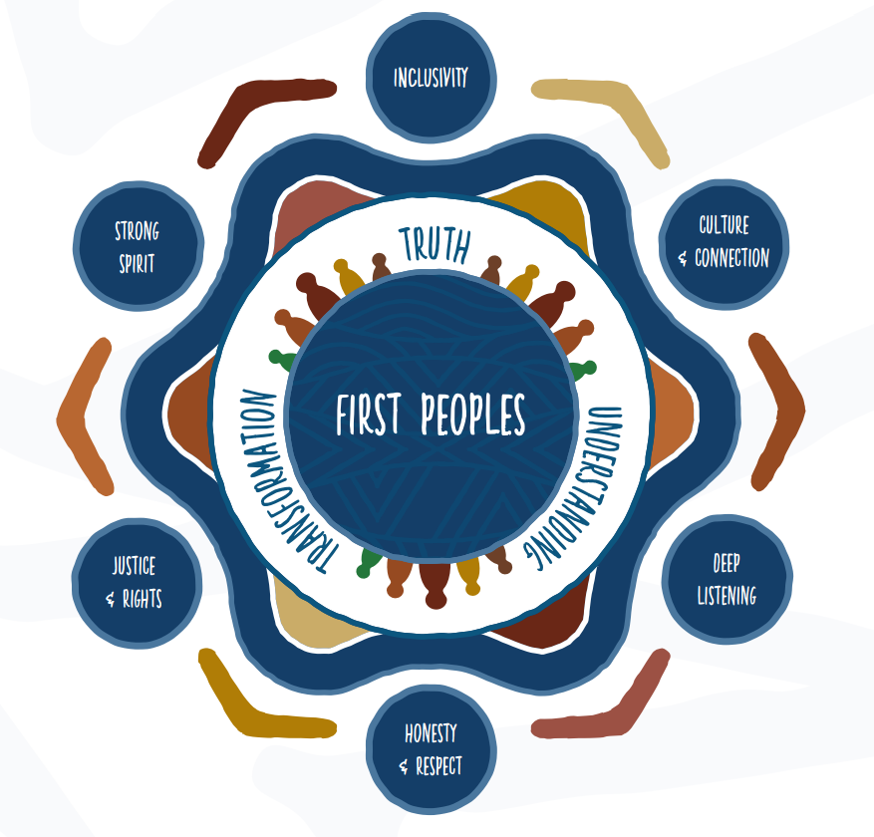

Position Summary
As part of the Yoorrook Justice Commission’s Social and Emotional Wellbeing team, this role delivers frontline trauma-informed, person-centred, and culturally safe services to participants. The key function of this role is to support participants in a trauma-informed way that minimises the potential for traumatisation/re-traumatisation through the truth-telling process.
The Social and Emotional Wellbeing (SEWB) team at the Yoorrook Justice Commission works in partnership with First People’s Health and Wellbeing (FPHW) to provide culturally appropriate, trauma-informed third-party counselling and wellbeing services to Yoorrook participants and staff. Yoorrook SEWB staff are seconded from Yoorrook to FPHW to ensure that clinical records are kept securely by FPHW (completely independent of Yoorrook’s records) in accordance with professional standards and applicable laws, in each case, as identified by FPHW as being applicable to the performance of the services. This also ensure that counselling and general wellbeing services provided to Yoorrook participants and staff are independent of Yoorrook’s operations.

Yoorrook’s mandate requires it to complete its work by 30 June 2024. Yoorrook has recommended to the Victorian Government that it extend this timeframe by two years to 30 June 2026.
Yoorrook’s Letters Patent requires it to prioritise the employment of First Peoples. Only First Peoples can apply for this position.
This role will require periodic travel across Victoria.
Classification | VPS 4
Term | 28 June 2024 (with possibility of extension)
Salary Range | $90,067 – 102,192 Range plus 10.5% employer superannuation contribution
Reports to | Senior Practitioner – Helen Thomas
Hours of work | Full time – 38 hours per week

Key Accountabilities
- Supporting the welfare, social and emotional wellbeing of participants of the Yoorrook Justice Commission processes. Providing a range of professional services including intake, counselling, assessment, referrals as required, and other evidence-based therapeutic wellbeing approaches.
- Providing crisis, counselling, and support for participants of the Yoorrook Justice Commission processes through face to face and telehealth services, responding to a high level of participant requests in a timely and effective manner and the provision of information and appropriate referral.
- Supporting participants within the Yoorrook Justice Commission multidisciplinary teams and service delivery model, including working alongside legal professionals, administration, and other engagement staff.
- Providing discipline-specific case consultation and support to co-workers within and external to the Yoorrook Justice Commission for the purposes of supporting the well-being of participants and minimising the impacts of engagement.
- Supporting Yoorrook Justice Commissions service delivery model, and providing expertise where required.
- Actively contribute to a positive, collaborative, innovative and culturally safe workplace culture that supports strong connections within the Social and Emotional Wellbeing team, and across the organisation, aligned with Yoorrook’s values and mandate.
- Other related tasks and duties as determined by the CEO or Senior Practitioner/Nominated Supervisor that are consistent with a position of this grade and skills requirement.
Key selection criteria
- Tertiary qualification in Social Work, Psychology or Counselling including current membership with a relevant professional body and relevant
- A strong understanding of culturally oriented social and emotional wellbeing knowledge and practice frameworks and models, with experience in utilising these in professional practice work preferably in trauma-informed and multi-disciplinary services.
- An understanding of colonisation in Victoria, culturally safe service provision and experience in working with First Peoples who have experienced trauma.
- Demonstrated ability to provide immediate and autonomous clinical judgement and crisis intervention in highly stressful, complex, and sensitive situations.
- Highly developed teamwork and stakeholder engagement skills including building successful referral relationships with other services.
- A high level of commitment to self-care, reflective practice, and supervision.
Additional information
Please note that as the work of Yoorrook is unprecedented, the focus of roles may be subject to change to ensure Yoorrook can be responsive to First Peoples’ needs and deliver on its mandate.

Yoorrook Commitment
Diversity and Equal Employment Opportunity
We welcome applicants from a diverse range of backgrounds and experiences, including Aboriginal and Torres Strait Islander peoples, people from culturally and linguistically diverse (CALD) backgrounds, people who identify as LGBTIQA+, people with disability, as diversity and inclusion drives our success.
It is important to us that candidates with disability can participate equitably in the recruitment process. If you need assistance or adjustments to fully participate in the application or interview process or if you have any enquiries about diversity and inclusion at Yoorrook, please contact 0412 597 791.
Supporting our employees balance their work and life commitments.
The nature and scope of flexible options available will depend on the nature of the position. Applicants are encouraged to discuss flexible arrangements with the hiring manager during the recruitment process.
Occupational health and safety responsibilities
In the context of OHS policies, procedures, training, and instruction, as detailed in Section 25 of the Occupational Health and Safety Act 2004, employees are responsible for ensuring they:
- Follow reasonable instruction
- Cooperate with their employer
- At all times, take reasonable care for the safety of others in the workplace.

Security requirements and professional obligations
- Pre-employment screening may apply to all appointments
- Preferred applicants may be asked to provide evidence of their qualifications
- All preferred applicants will be required to produce sufficient proof of their identity prior to commencing employment with the department
- Employment of successful candidates may be subject to a National Police Check

To receive this publication in an accessible format, please contact 0412 597 791 using the National Relay Service 13 36 77 if required (for more information visit www.relayservice.gov.au).

